

LAB 06

# Summary

|  |  |
| --- | --- |
| **Items** | **Description** |
| Course Title | Programming Fundamentals |
| Lab Title | Operators in C++ |
| Duration | 3 Hours |
| Operating  System/Tool/ Language | Ubuntu/ g++/ C++ |
| Objective | To get familiar with use of switch statement and ternary operator |

## Switch Statements

### The ***switch statement*** allows us to execute a block of code among many alternatives. The syntax of the switch statement in C++ is:

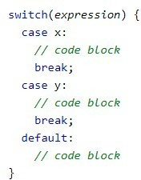

This is how it works:

* The switch expression is evaluated once
* The value of the expression is compared with the values of each case
* If there is a match, the associated block of code is executed
* The break and default keywords are optional, and will be described later in this chapter

## Example 01

### The example below uses the Number and will tell you if it’s a weekend or not



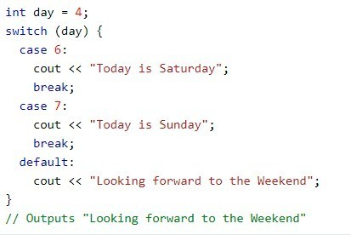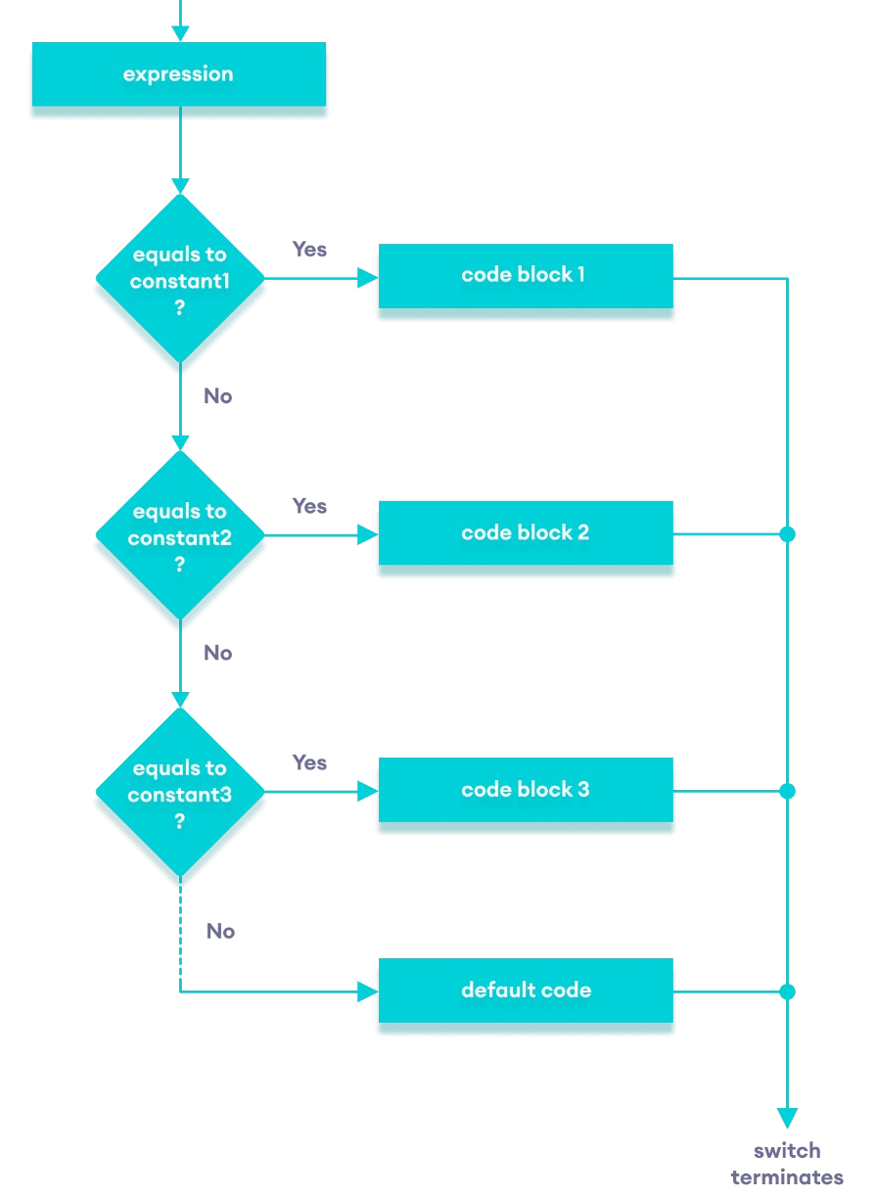

**FIGURE 1 FLOWCHART OF C++ SWITCH...CASE STATEMENT**



# The break Keyword

### When C++ reaches a break keyword, it breaks out of the switch block. This will stop the execution of more code and case testing inside the block.

When a match is found, and the job is done, it's time for a break. There is no need for more testing.



# The default Keyword

The default keyword specifies some code to run if there is no case match:

**Example 02**

### The example below uses the weekday number to calculate the weekday name

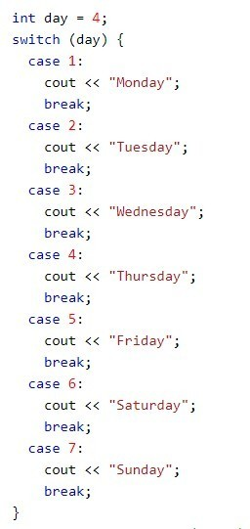



***Output: Thursday***

*Note: We can do the same thing with the if...else. If ladder. However, the syntax of the switch statement is cleaner and much easier to read and write.*

## Lab Tasks

**Task#01**

**Use switch statement**

Write a program to ask a student to enter his/her GPA. The program should display letter grade according to following criteria:

|  |  |
| --- | --- |
| **CGPA** | **GRADE** |
| 4 | A+ |
| 3 | A |
| 2 | B |
| 1 | C |

*Note: Please don’t consider floating point numbers.*

**Task#02**

**Use Switch statement**

1. Calculator: Write a c++ program that will display the following menu options to the user.

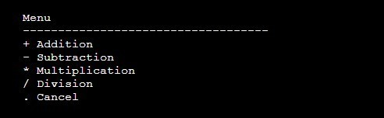

* + Take 2 numbers and an operator as an input from the user.
  + Perform calculations according to the operator entered by the user.

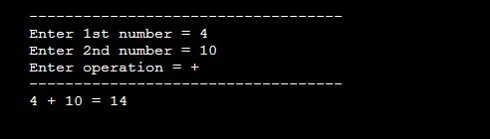



### **Task#03**

**Use Switch statement**

Write a c++ program to check whether an input value is an alphabet, digit or a special character.

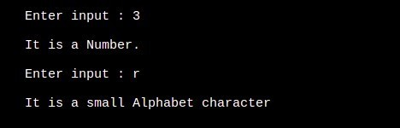

### **Task#04**

**Use ternary operator**

Write a program that reads score of a student in a subject and displays his grades according to the following criteria:

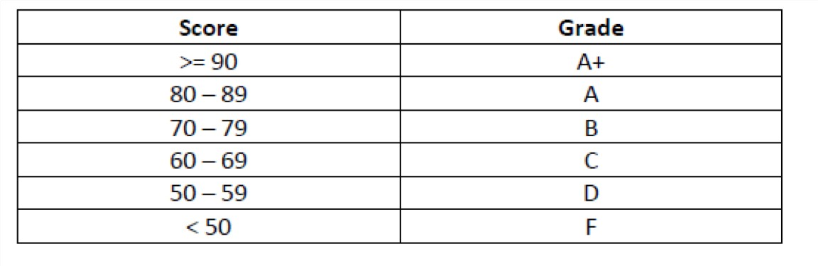

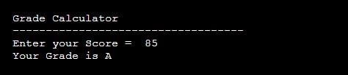Output



### **Task#05**

**Use Switch statement**

Please ask user to enter a number and print the weekday. (Assume first day is Friday)

### **Task#06**

**Use ternary operator.**

Calculate the bill and let user enter the number of units consumed.

Details:

### if (units<=50) = Rs. 0.50/unit

### (units<=150) = Rs. 0.75/unit

### (units<=250) = Rs. 1.20/unit

### For unit above 250 Rs. 1.50/unit

An additional amount 20% is added to the bill.

### **Task#07**

Write a c++ program that will take two integer values from the user and display whether the first number is greater, smaller or equal to the second number.

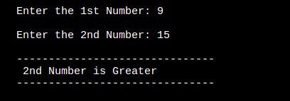On the basis of that decision, if the first number is not greater than second number you program should check whether the second number is greater, smaller or equal to the first number. **(using nested switch case)**



**Submission Instructions:**

Submit cpp files. Naming Convention of files must be as follows:  
 rollnum_Task1 (i.e 23i-1234_Task1.cpp)  
  
Note: Don't submit zip folder.